The [free upgrade for Windows 10](http://windowsreport.com/windows-10-creators-update-free-upgrade/) was available to everyone at one point. The upgrade disabled microphone in PCs across the world. Some users will get frustrated easily and go out to buy a [external sound card](http://shop.ebay.com/?&_nkw=external%20sound%20card) but for those users who would like to troubleshoot the issue take a look at the following solutions.

**Enable the microphone from the Device Manager**

The microphone can be turned on with Windows tools. To do this, access the [Device Manager](http://windowsreport.com/remove-drives-device-manager/) in Windows by performing the following steps:

1. Access the **Winx Menu** by simultaneously pressing the **Windows** key and **X.**
2. Select **Device Manager** from the list.

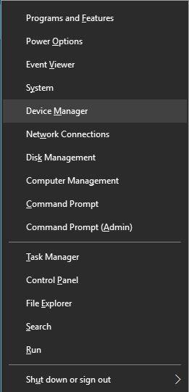

1. Click on **Sound Video and**[**Game Controllers**](http://skimlinks.pgpartner.com/mrdr.php?url=http%3A%2F%2Fskimlinks.pgpartner.com%2Fsearch.php%2Fform_keyword%3Dgame%2Bcontrollers) once **Device Manager** is open.
2. Click on the sound card that is currently installed in the **PC.**
3. **Right click** and choose **Enable.**
4. **Restart** the computer to finish the process.

**Note: Once the computer has restarted the drivers for the sound card should reinstall and enable the microphone to work properly. If there is a yellow warning icon beside the name of the sound controller the drivers for that controller are either damaged or uninstalled.**

1. Uninstall the device and restart the computer if there is a yellow warning icon beside the name of the sound controller. The sound controller will automatically re-install the audio controller.

**Enable microphone from the Sound Settings**

The microphone can be enabled and disabled from the sound settings. To enable the microphone from the sound settings perform the following tasks:

1. **Right Click** on the **Sound Settings Icon** at the bottom right corner of the windows menu**.**
2. Scroll up and select **Recording Devices.**
3. Click on **Recording**.
4. **Right Click** on the desired device (if there are devices listed).
5. Select **Enable**.

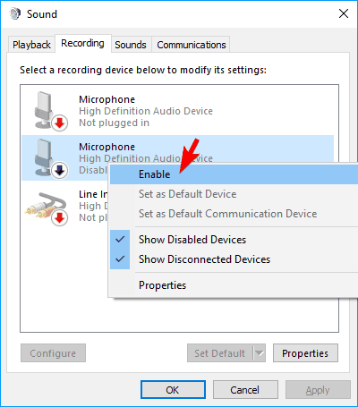

**Note:** If you don’t see the installed microphone this is an indication that the microphone is disabled.

1. **Right Click** anywhere in the window and select **Show Disabled Devices.**
2. Select the desired microphone from the generated list.
3. Click on **Properties.**
4. Using the drop down list at the bottom of the window under **Device Usage** select **Use this Device (Enable)**.
5. Click on **Apply.**
6. Click on **OK.**
7. Ensure that the selected device is set to default.

**Note: The green check mark outlined by a circle is the indicating symbol that the device is default.**

**Enable the microphone from Windows Settings**

To change the Windows setting that allows the PC to access the microphone complete the following steps:

1. Access **Windows Settings** by simultaneously pressing the **Windows Key** and **I**.

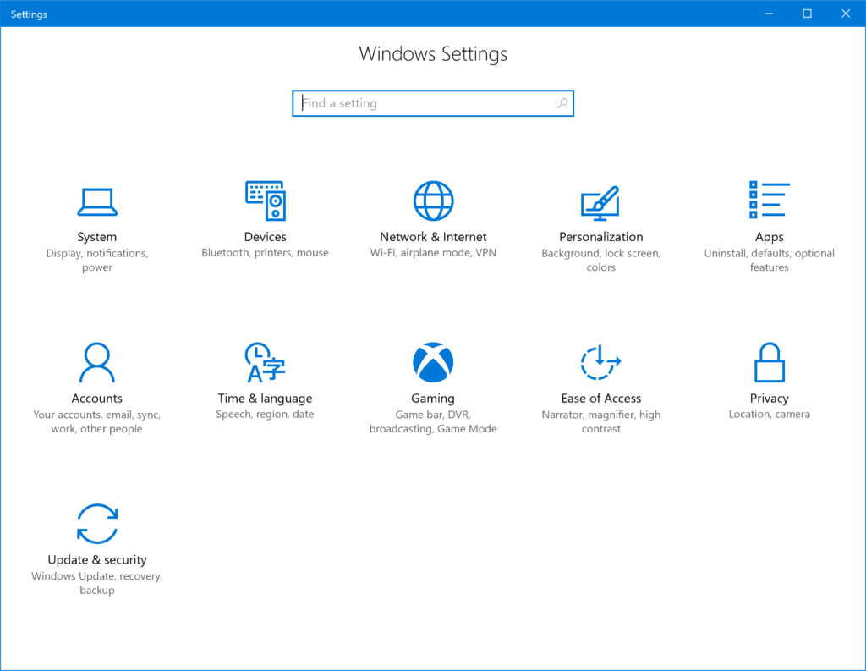

1. Click on **Privacy**.
2. Choose **Microphone** on the left menu.

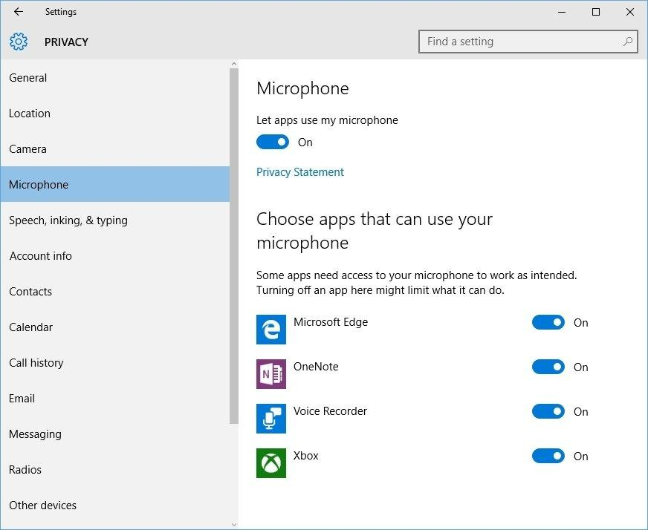

1. Navigate to the microphone settings. Under **Let apps use my microphone** ensure that the indicator is set to **On**.
2. Click on the icon and move it to the other side of the colored portion of the switch if the indicator is set to **Off**.

If these solutions do not work to resolve the issues with the microphone there may be damage to the computer’s hardware. Hardware issues can be resolved by buying external components or having new internal components installed. Buying external components to resolve this issue may be the most inexpensive way to fix the issue. Resolving sound issues can take a few restarts and re-installations. Be sure to exhaust all options before buying new hardware.